Title: Professor
Name & Address: David Elliott, Institute for Genetic Medicine, Newcastle University, Central Parkway, Newcastle NE1 3BZ

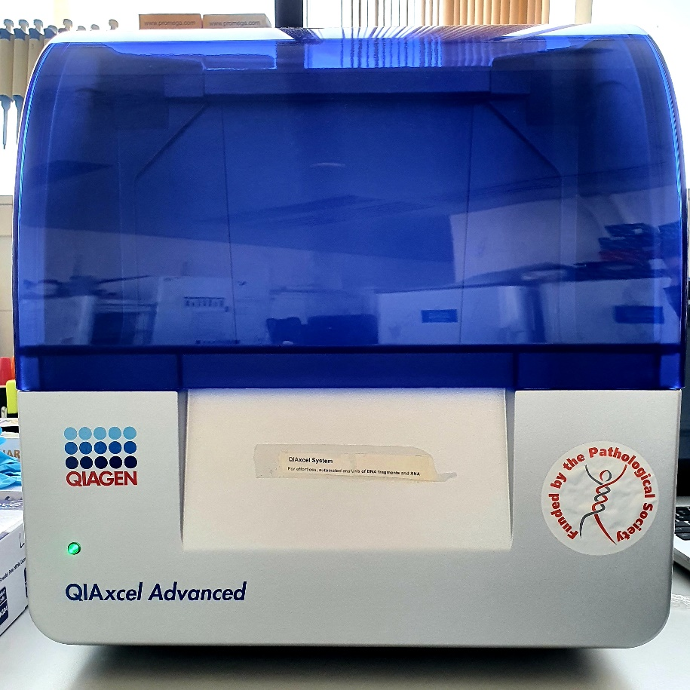
Type of equipment: We are very grateful for the award of an equipment grant to make possible the purchase of a Qiaxcel Advanced capillary gele lectrophoresis machine and associated PC/software. This purchase was also part funded by Newcastle University.

Our Qiaxcel machine is in use daily, and enables rapid analysis of up to 96 samples in parallel of DNA, RNA or protein, (depending on the cartridge that is loaded). Important features of this machine are
(1) It is much quicker and safer than conventional gel electrophoresis, with no need to make and stain gels. The rapid, high throughput analysis of samples with very little downtime makes this machine perfect to be shared between research projects (96 separate samples have a run time of just 12 minutes, whereas a typical agarose or polyacrylamide gel would take at least 1 hour to analyse a small fraction of these samples. The Qiaxcel Advanced machine also is fully automatic, so there is no requirement to individually load wells –a huge timesaver compared to traditional electrophoresis. (2) High sensitivity using low sample volumes (just 0.5ul) thus meaning that valuable samples such as those from patients or organoids can be used sparingly.
(3) Digital readout. There is a digital readout that can be stored, and used for publication quality images (see figure for typical analysis output on the PC screen for DNA fragments run in parallel on the machine), The PC comes with software for quantitative analyses of products.
(4) High resolution, enabling very small to very large molecules to be separated. This includes when necessary resolving molecules with only several nucleotide size differences, which is often important but challenging with conventional agarose gel electrophoresis.
(5) Increased safety. Conventional analysis requires the user to make gels containing ethidium bromide (a carcinogen) or acrylamide (a highly toxic putative carcinogen) respectively. These are not required for the Qiaxcel system.

This Qiaxcel machine has been used so far for for three purposes by groups in Newcastle University Faculty of Medical Sciences:

- Quantitation of splice isoforms. The Qiaxcel has been used to analyse RT-PCR experiments that detect mRNAisoforms. This has enabled us to quantitate splice isoforms after depletion of particular splicing factors in cancer cells (see Figure for example data from the Pathological Society student Alice Coomer). This figure shows the sensitivity of analysis, as there are some strong splice isoform changes like CHEK1, but also much weaker changes including MTA1 and FAM118B which have very subtle changes that would be difficult to detect on a conventional gel. Our Qiaxcel machine has also been used to detect and quantify mRNA splice isoform switches in cell lines derived from patients with genetic diseases impacting splicing regulation.

- Analysis of very valuable DNA samples prior to next generation sequencing. The Qiaxcel is perfect for this as 0.5ul volumes can be analysed, thus not depleting stocks. For example groups in Newcastle University have used the Qiaxcel for monitoring the size distributions and quality of libraries of binding sites for RNA binding proteins prepared by iCLIP, for evaluation prior to sequencing. CLIP has several steps where small volumes of amplicon need to be analysed, for which the Qiaxcel Advanced machine is much more efficient than a conventional gel. These CLIP experiments help to characterise disease mechanisms by identifying binding sites for RNA binding proteins by immunoprecipitation of crosslinked RNA binding proteins, followed by RT-PCR of associated RNAs.

- To develop a test of microsatellite instability (MSI) of tumour samples from patients with colorectal cancer. The Qiaxcel Advanced machine has been used to monitor amplicons prior to pooling for multiplexed next generation sequencing. The MSI assays are being designed to complement pathological analysis of tumour specimens (e.g. Hum Mutat. 2019 May;40(5):649-655), using DNA from FFPE curls as the main template. It is hoped this test will be used as a companion diagnostic for immunotherapy in multiple tumour types, as well as a faster and cheaper routine assay for MSI. Supporting this, MSI is now being used as a screening tool in some populations for Lynch Syndrome.

Figure showing example generated using our Qiaxcel machine. A. Qiaxcel images as validation for splice variants identified by RNAseq. B. Quantitation of splicing changes measured using the qiaxcel and plotted using a heatmap.

